**Topics: Descriptive Statistics and Probability**

1. Look at the data given below. Plot the data, find the outliers and find out $μ, σ, σ^{2}$

|  |  |
| --- | --- |
| **Name of company** | **Measure X** |
| Allied Signal | 24.23% |
| Bankers Trust | 25.53% |
| General Mills | 25.41% |
| ITT Industries | 24.14% |
| J.P.Morgan & Co. | 29.62% |
| Lehman Brothers | 28.25% |
| Marriott | 25.81% |
| MCI | 24.39% |
| Merrill Lynch | 40.26% |
| Microsoft | 32.95% |
| Morgan Stanley | 91.36% |
| Sun Microsystems | 25.99% |
| Travelers | 39.42% |
| US Airways | 26.71% |
| Warner-Lambert | 35.00% |

Answer:-

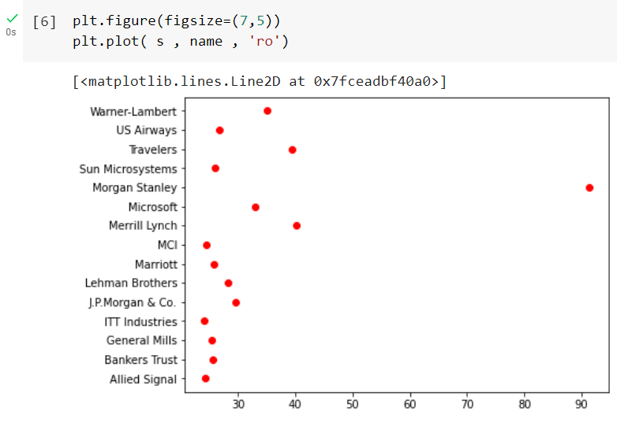

For $μ$ (Mean)

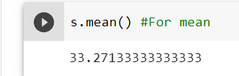

For $σ$ (Standard Deviation)

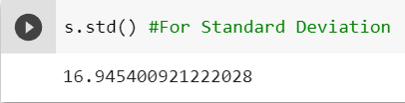

For $σ^{2}$ (Variance)

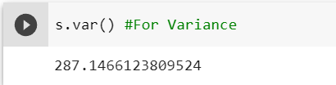

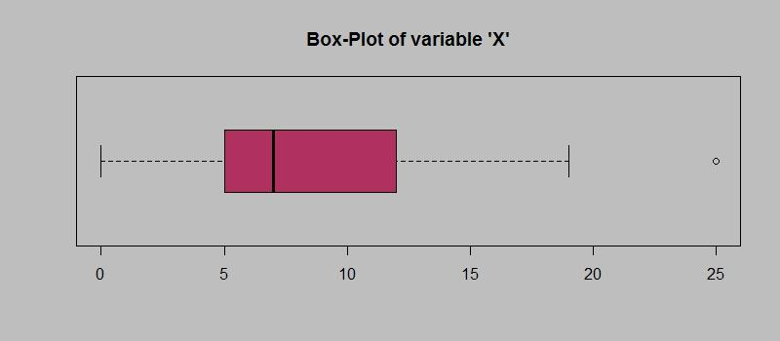

Answer the following three questions based on the box-plot above.

1. What is the interquartile range of this dataset? (please approximate the numbers) In one line, explain what this value implies.

Answer:- Approximately, (First Quantile Range) Q1 = 5

(Third Quantile Range) Q3 = 12

(Second Quartile Range) Median = 7

(Interquartile Range) IQR = Q3 – Q1 = 12 – 5 = 7

1. What can we say about the skewness of this dataset?

Answer:- The median is right-skewed and leans to the left; this is not a normal distribution.

1. If it was found that the data point with the value 25 is actually 2.5, how would the new box-plot be affected?

Answer:- In such instance, there wouldn't be any outliers on the dataset because the outlier caused the data's positive skewness to decrease, resulting in a normal distribution of the data.

3.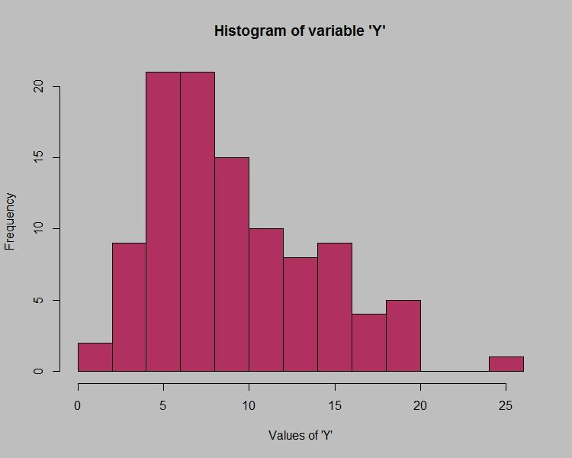

Answer the following three questions based on the histogram above.

1. Where would the mode of this dataset lie?

Answer:- The mode of that kind of data set is between 5 and 10, with an approximate range

of 4 to 8.

1. Comment on the skewness of the dataset.

Answer:- Right-Skewed.

Mean>Median>Mode

1. Suppose that the above histogram and the box-plot in question 2 are plotted for the same dataset. Explain how these graphs complement each other in providing information about any dataset.

Answer:- The median can be easily observed in a box plot, whereas the histogram mode makes it more obvious. They are both right-skewed and have outliers.

1. AT&T was running commercials in 1990 aimed at luring back customers who had switched to one of the other long-distance phone service providers. One such commercial shows a businessman trying to reach Phoenix and mistakenly getting Fiji, where a half-naked native on a beach responds incomprehensibly in Polynesian. When asked about this advertisement, AT&T admitted that the portrayed incident did not actually take place but added that this was an enactment of something that “could happen.” Suppose that one in 200 long-distance telephone calls is misdirected. What is the probability that at least one in five attempted telephone calls reaches the wrong number? (Assume independence of attempts.)

Answer:-

If one in every 200 long-distance phone calls gets misrouted.

Possibility of call misdirection = 1/200.

Probability of not calling Irresponsible = 1-1/200 = 199/200.

At least one out of every five phone calls that are made is likely to go to the incorrect number.

Number of Calls (n)= 5

p = 1/200

q = 199/200

P(x) = At least one out of every five phone calls tries to contact the erroneous number

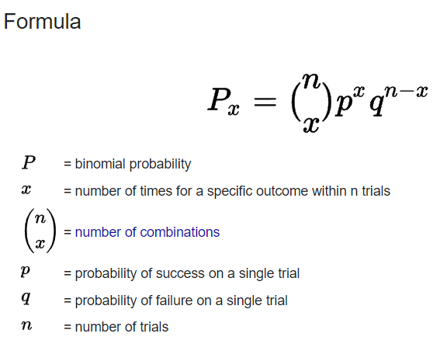

P(1) = (5C1) (1/200)^1 (199/200)^5-1

P(1) = 0.0245037

1. Returns on a certain business venture, to the nearest $1,000, are known to follow the following probability distribution

|  |  |
| --- | --- |
| x | P(x) |
| -2,000 | 0.1 |
| -1,000 | 0.1 |
| 0 | 0.2 |
| 1000 | 0.2 |
| 2000 | 0.3 |
| 3000 | 0.1 |

Answer:-

E(X)=μ=∑xP(x)

= -200

= -100

= 0

= 200

= 600

= 300

Total = 800

E(X2) = Σx2 * p(x)

= 400000

= 100000

= 200000

=1200000

= 900000

Total = 2800000

1. What is the most likely monetary outcome of the business venture?

Answer: - The business venture's expected financial return is $2000.

In comparison to other amounts, the likelihood for $2000 is the highest at 0.3

1. Is the venture likely to be successful? Explain

Answer: - For calculating venture to be successful, multiply each monetary result by the associated probability to determine the expected return, then add the results.

Expected Return = (-2,000 * 0.1) + (-1,000 * 0.1) + (0 * 0.2) + (1,000 * 0.2) + (2,000 * 0.3) + (3,000 * 0.1)

Expected Return = -200 + (-100) + 0 + 200 + 600 + 300

Expected Return = 800

The investment is anticipated to yield a $800 profit. The initiative is probably going to succeed on average because the expected return is positive.

1. What is the long-term average earning of business ventures of this kind? Explain

Answer:- The long-term average, Expected value = Sum (X * P(X)) = 800$,

indicates that returns will typically be positive 800$.

1. What is the good measure of the risk involved in a venture of this kind? Compute this measure

Answer: - We can compute the variance or standard deviation of the probability distribution to assess the risk associated with an undertaking. The degree to which the values deviate from the expected return is quantified by the variance and standard deviation.

For calculation Variance:

Variance = [(-2,000 - 800) ^2 * 0.1] + [(-1,000 - 800) ^2 * 0.1] + [(0 - 800) ^2 * 0.2] + [(1,000 - 800) ^2 * 0.2] + [(2,000 - 800) ^2 * 0.3] + [(3,000 - 800) ^2 * 0.1]

Variance = [(-2,800) ^2 * 0.1] + [(-1,800) ^2 * 0.1] + [(-800) ^2 * 0.2] + [(200) ^2 * 0.2] + [(1,200) ^2 * 0.3] + [(2,200) ^2 * 0.1]

Variance = [7,840,000 * 0.1] + [3,240,000 * 0.1] + [640,000 * 0.2] + [40,000 * 0.2] + [1,440,000 * 0.3] + [4,840,000 * 0.1]

Variance = 784,000 + 324,000 + 128,000 + 8,000 + 432,000 + 484,000

Variance = 2,160,000

Var (X) = E(X^2) –(E(X)) ^2

= 2800000 – 800^2

= 2160000

To compute the standard deviation, we take the square root of the variance:

Standard Deviation = √2,160,000

Standard Deviation ≈ 1,469

Consequently, the venture's standard deviation is around 1,469. The risk associated with the venture is well captured by the standard deviation. Greater unpredictability or risk is indicated by a higher standard deviation, which suggests that actual returns may vary more from expected returns.